# Unity Tutorial: Car Controller with script

**Step 1**: Open **Unity** and go to your **Scene**

To make your life easier: Let’s assume you have a car model and if you do not, feel free to use the standard assets or just make a square box and assume that as a car model.

**Step 2**: First make sure you have created a base box and change its Position to ***X:0, Y:1, Z:0***

And change its Scale to ***X: 55, Y: 0.05, Z: 55***

Then place the Car Model on top of that

Let’s call it SkyCar for now

Then Right Click SkyCar and Create Empty

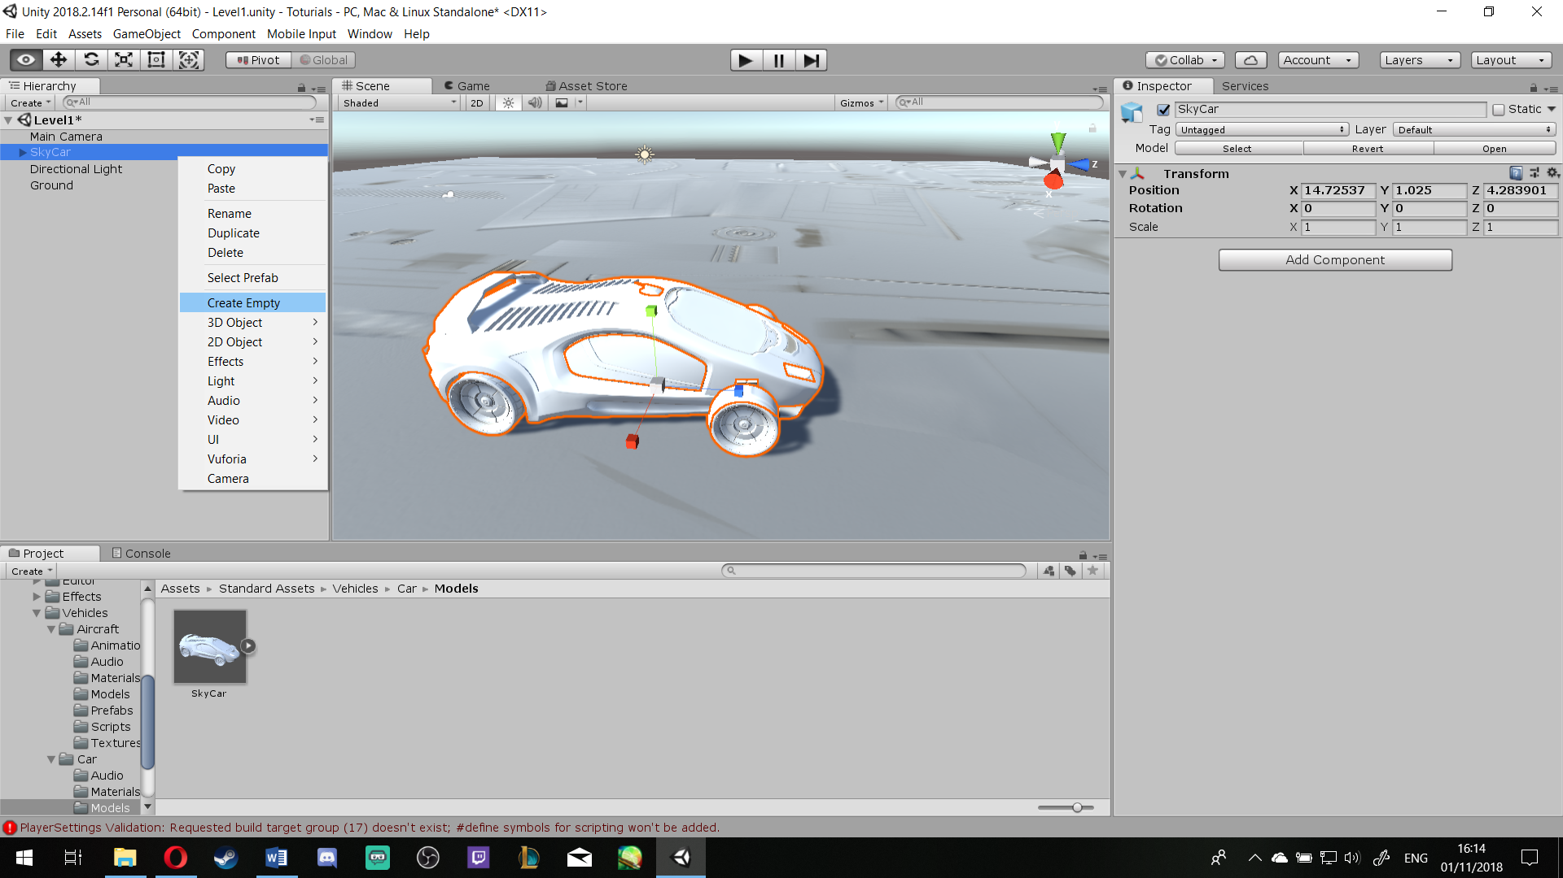Then rename it to WheelTransforms

To make your life easier: rename your Wheels to, **FL, FR, BL** and **BR** for front left, front right and so on.

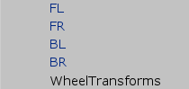

Then select them all and put them in the Sub Section of Wheel Transforms

To make your life easier: Now would be a good time to adjust the camera on your car (click on Main Camera and use the QWERT to adjust to your liking.

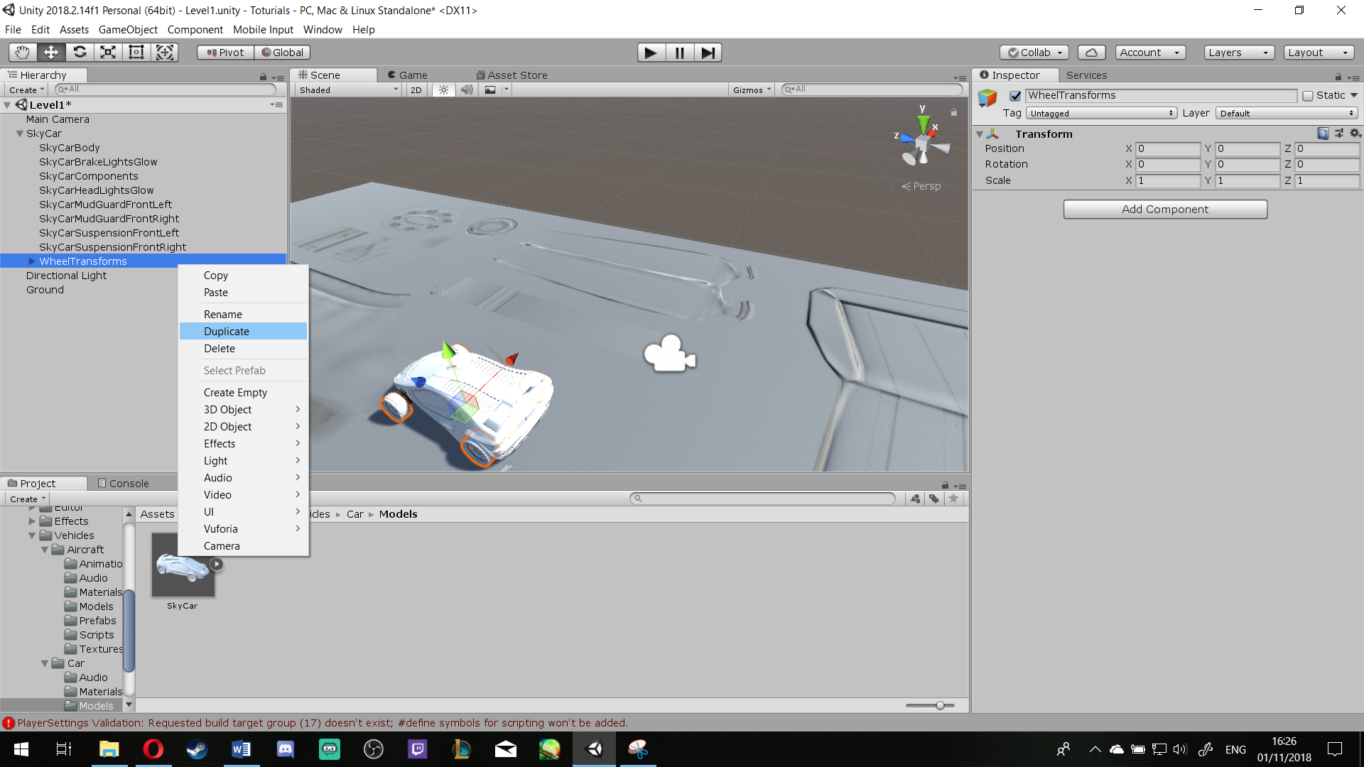Now Right Click on WheelTransforms and **Duplicate** it

**Rename** it to WheelColliders, then open the sub rout and select all 4 wheels [ASB]

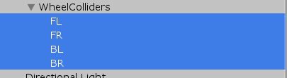

Make sure you Remove Component the **Mesh Filter** and **Mesh Renderer** for all 4 wheels [ASB]

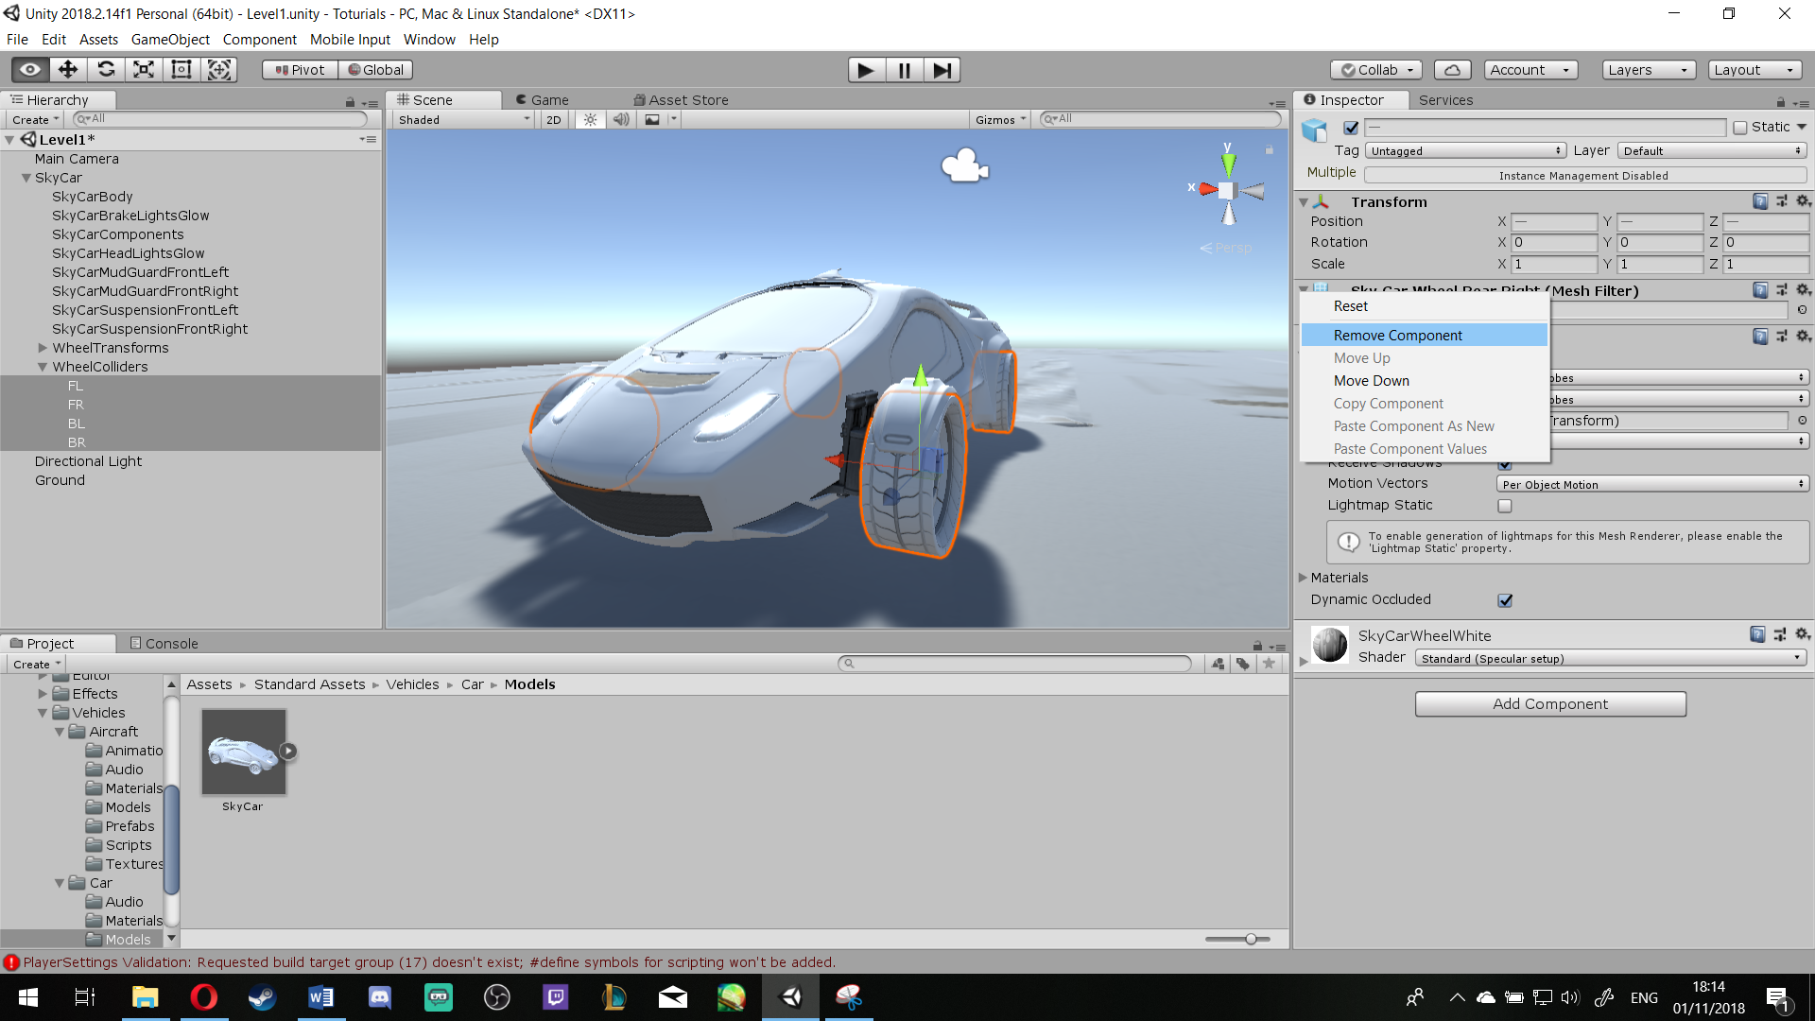



Then make sure their **Scale** is ***X: 1, Y: 1, Z: 1*** [ASB]

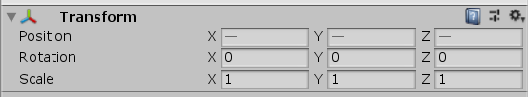

Having them still selected, **Add New Component** > **Wheel Collider** [ASB]

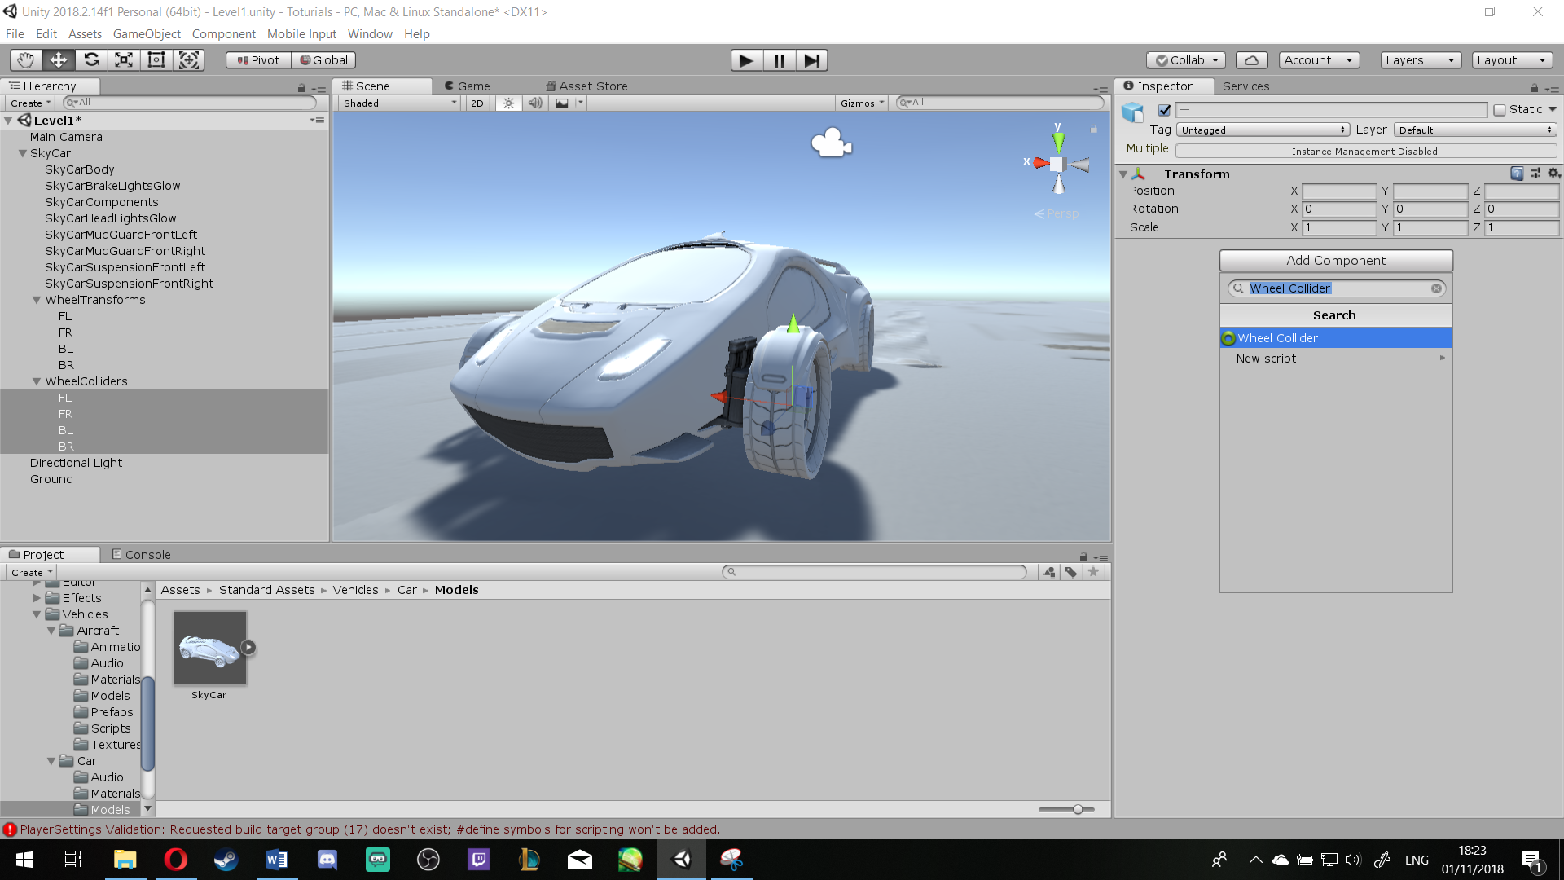

Make the **Radius = 2.7** [ASB]

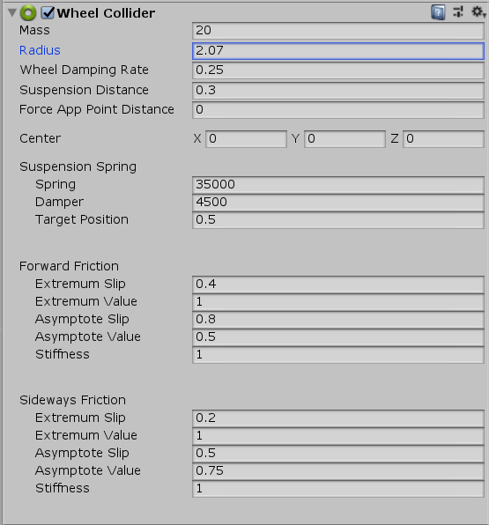

Then Select the SkyCar at the **Hierarchy** > **Add Component** > **Rigidbody**

Change the **Mass** to **1000** (For now, you might want to change this value if you feel your car is not fast enough)

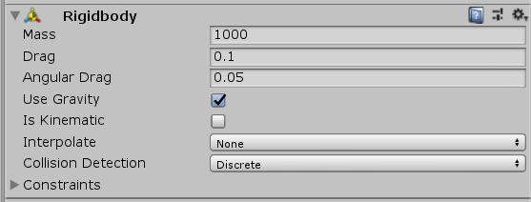Also change **Drag** to **0.1** [ASB]

Then go back to the **WheelColliders** > **Select all 4 Wheels**

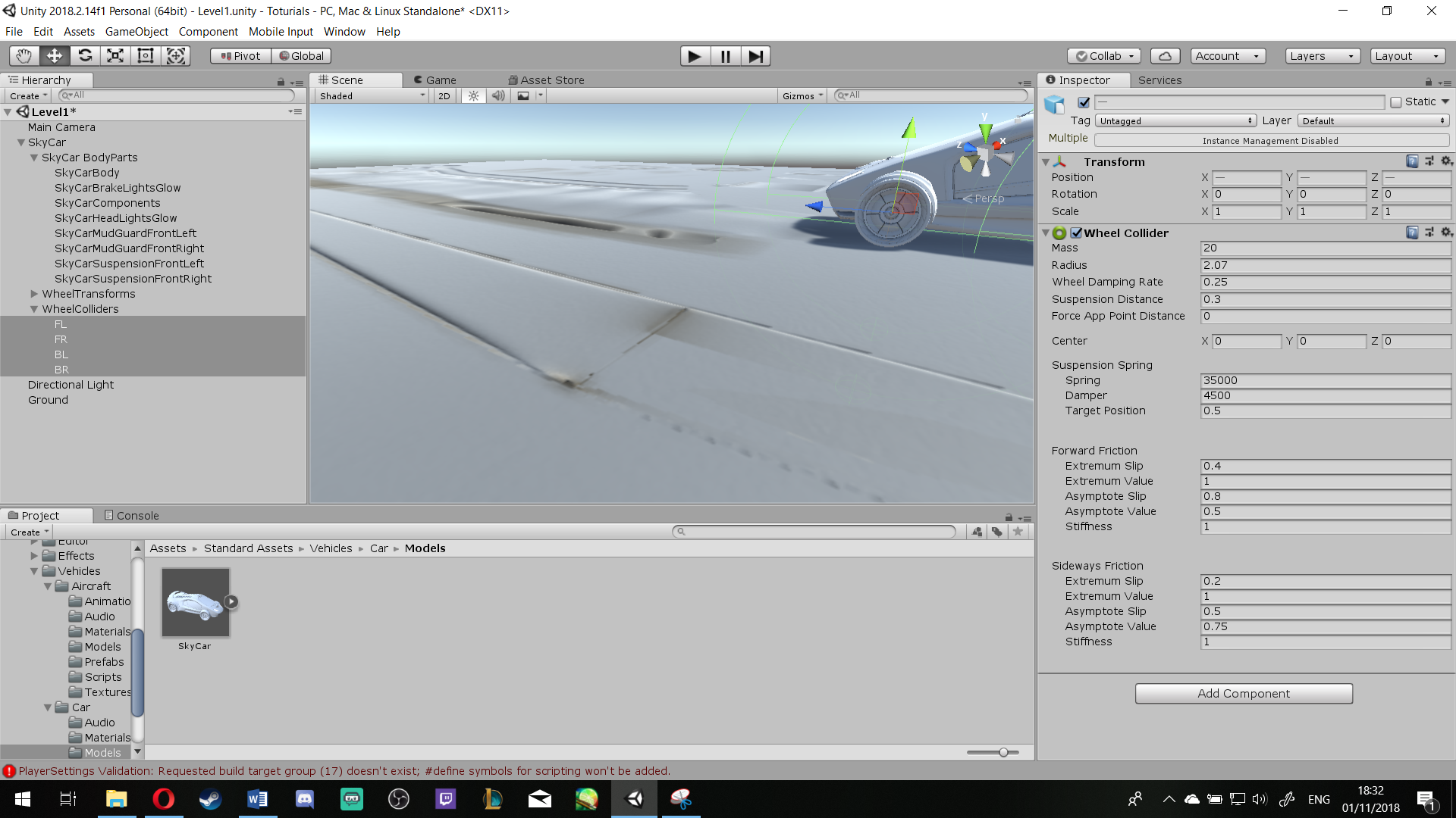Then using the side view (*To do that, you can use the View Navigator on top right*) [ASB]

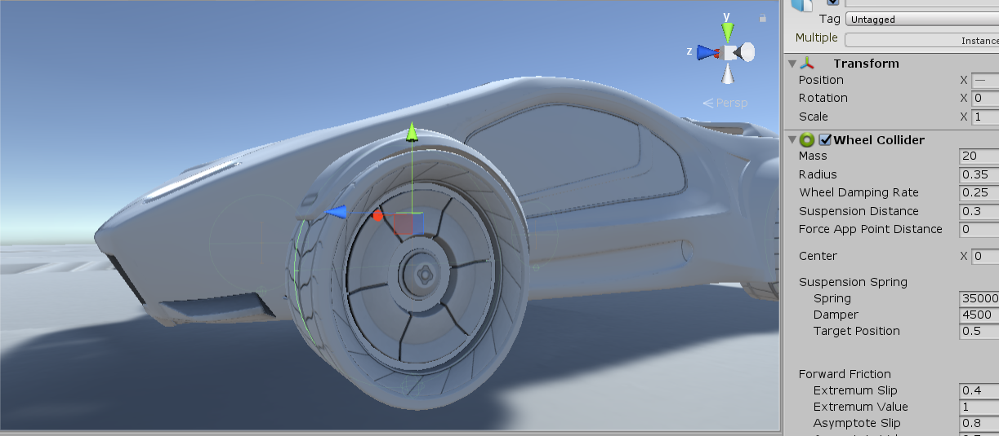**Step 3**: Change the **Radius** till the Green lines match the shape of the wheels [ASB]

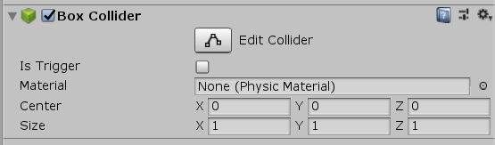Then Select **SkyCar** > **Add Component** > **Box Collider** [ASB]

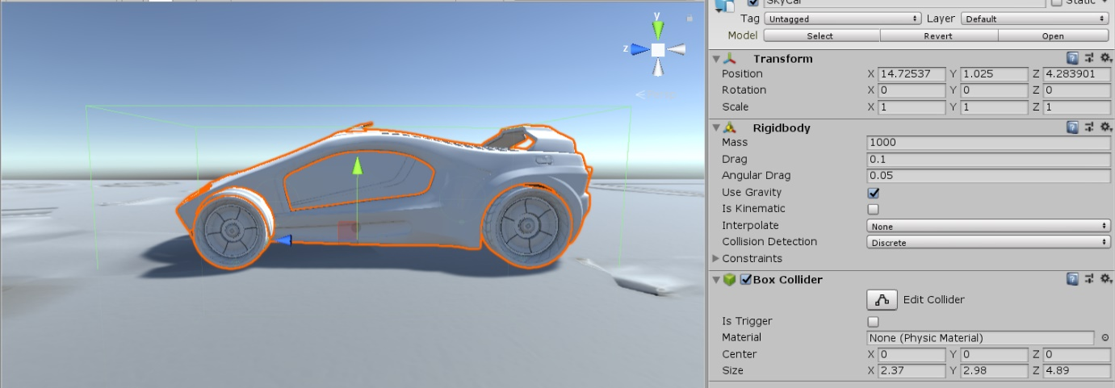Then change its **size** so your car would **fit** inside of the **green ‘Box’** [ASB]

**Step 4**: **SkyCar** > **Add Component** > **New Script** > **CarController**

To make your life easier: Go to your Asset and make sure you move your **Script** into your Script Folder

Then > **Open the Script**

**Just so you know:** You need to implement the Wheel Colliders, Wheel Game object, Top Speed, Maximum Torque and so on, to do that use the code below and pay attention to the comments to understand the **behaviour of the code** and its **grammar**, Comments are followed ‘//’ and are in green.

**Step 5**: Follow these codes:

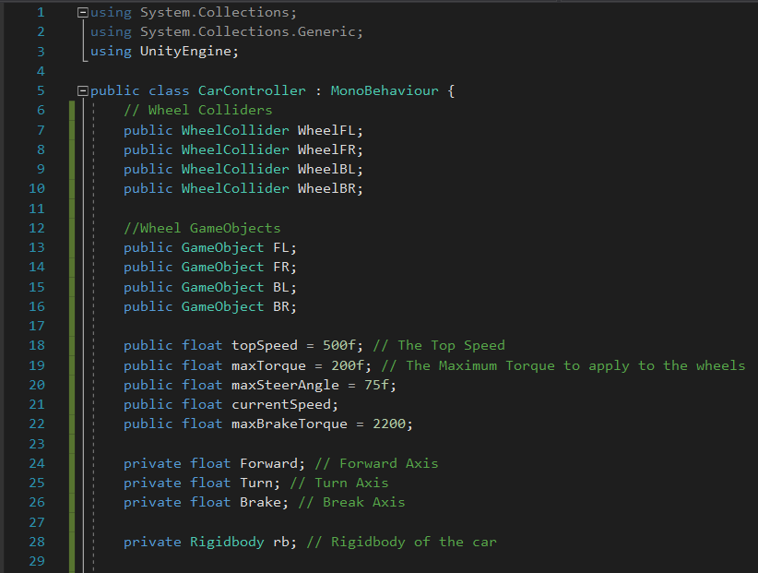The definition part:

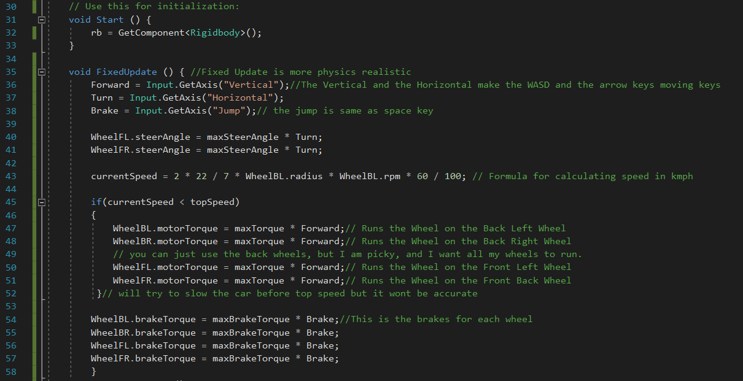The Void Start and the Void FixUpdate:

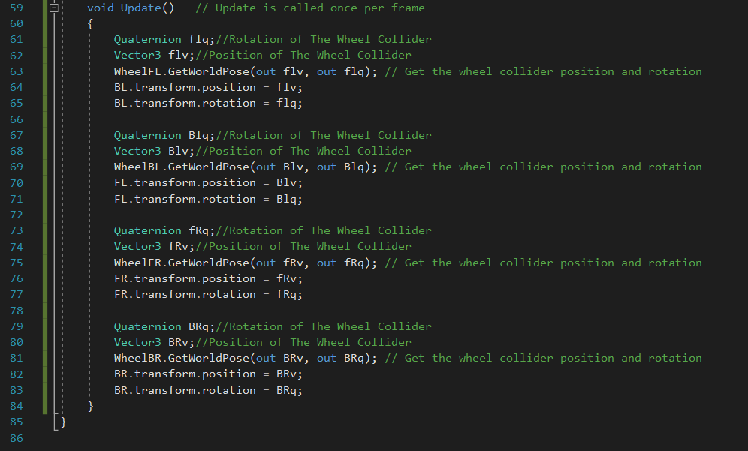The Void Update:

**Then Save all** and return to **Unity**

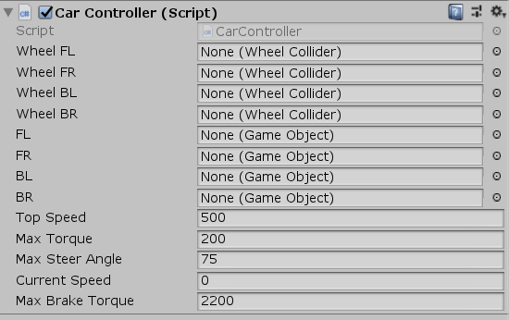**Step 6**: When you returned to unity, Under SkyCar **Inspections**, you should have a bigger section for script than you did before [ASB]

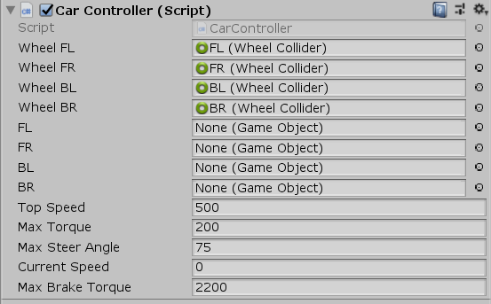Then open the **WheelCollider** sub route in Hierarchy and drag and drop FL for Wheel FL, FR for Wheel FR and so on [ASB]

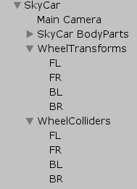

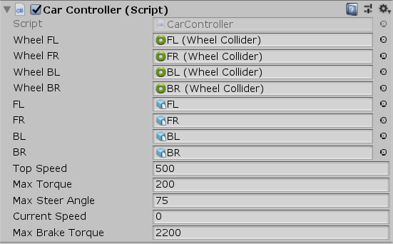Then do the same for **WheelTransforms** for the next four spaces below it [ASB]



**Step 7**: Drag the **Main Camera** and drop it under sub rout of **SkyCar** so the camera follows the car [ASB]

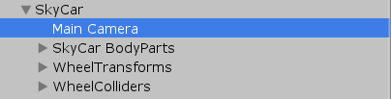

**Step 8**: Save your work and Enjoy the ride 😊